APPENDIX B-10: Extra Duty Compensation

A. The stipend of extra duty compensation for faculty who are assigned as performing arts instructors, coaches, and
project journalism instructors shall be as listed below in 1, 2 and 3. Stipends for regular faculty shall be paid over 5 or 10
months by employee request. Stipends for temporary faculty shall be paid over 5 months.

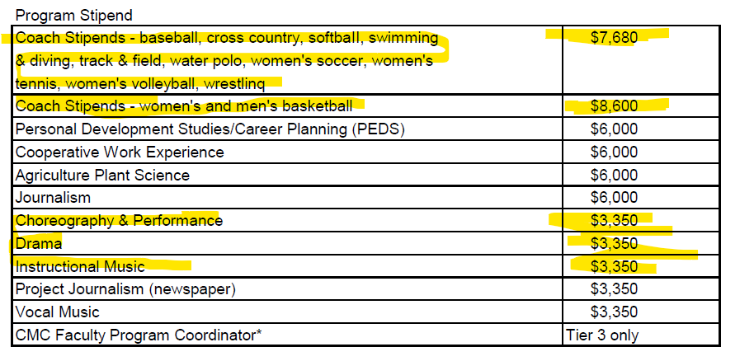

OLD TABLE:
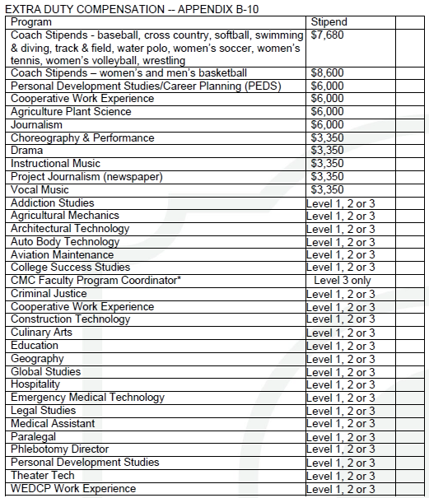
*A lead faculty coordinator will be assigned to California Men’s Colony (CMC) for the purposes of coordinating faculty orientation and trainings and act as liaison between faculty, the CMC Program Coordinator, and the Academic Senate Council.
B. Extra-duty stipends require pre-approval from the appropriate dean. Approval of an extra-duty stipend does not set a
precedence for an individual faculty member or program to receive a stipend in the future. The stipend of extra-duty
compensation shall be as follows:

Supplemental Duty Type:

Tier 1 – Programs with one to two (1-2) courses and CPPR. The district will provide a stipend of $250 total for
a PT faculty member for completion of an annual or biennial program review document (APPW or CTER), and
$500 total for the comprehensive program review document (CPPR). The stipend may be split between up to 3 part-time faculty who agree to collaborate on program review documents.

Tier 2 – Programs with 3 or more courses will receive an additional $100 per course assigned for completion
of each program review document (APPW, CTER or CPPR) not to exceed the stipend amount of Level 3.

Tier 3 – Programs with faculty responsible for textbook ordering, writing course materials/lab manuals,
management of other faculty schedules, organization of course materials, paid at $2880 per semester;
Or

Multiple courses with ancillary duties: to include such examples as advisory board representation, community outreach requirements for internship/externship, management of teaching assistants, paid at $2880 per semester.

A statement of work (SOW) is required for all stipends for Tier 2 or Tier 3.

C. A faculty member who is assigned by the District to perform work in addition to regular assigned duties shall be
compensated at the Ancillary of the faculty member's step and column for all authorized hours.
D. The hourly rate for substitute teaching shall be based on the faculty member's Step/Column of the
temporary (part-time) laboratory
hourly faculty salary schedule per compensated classroom hour of instruction.

D.1 Temporary faculty may substitute for another instructor (including service faculty) on a day-to-day basis without any change in their employment status (day-to-day substitution will not increase their assigned loading). Day-to-day substitution means substitute assignments of one or more days, consecutive or otherwise, when the instructor of record will be returning after a short-term absence. Substitute service of consecutive class periods for an instruction or a single CRN of more than 12.5% of the original assignment will be treated as a long-term substitute assignment and the assignment will be counted as load from the initial date of assignment. The long-term substitute designation may begin at the beginning of the substitute assignment if the absence of the instructor is expected to be greater than 12.5% of the total CRN load. Repeated day-to-day substitution for the same CRN and same instructor over the the course of a semester does not equate to long-term substitution.

E. A lead faculty coordinator will be assigned to California Men’s Colony (CMC) for the purposes of coordinating faculty
orientation and trainings and act as liaison between faculty, the CMC Program Coordinator, and the Academic Senate
Council. The compensation for this assignment will be the same as that of a faculty lead, $2880 stipend per semester.

F. Effective Fall 2025, faculty who teach MUS 212 will be compensated at their range and step on the Temporary, Part-Time & Full-Time Overload Laboratory/Hourly Faculty Salary Schedule.

